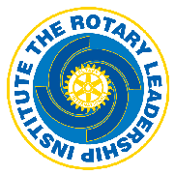

ROTARY LEADERSHIP INSTITUTE—

an exciting opportunity that lets you:

* Gain valuable skills that impact your leadership potential in both your vocation and your club
* Increase your understanding of Rotary
* Make new contacts and get fresh ideas

Saturday, June 15, 2019

Check In: 8:30 am

Program: 9:00 am to 3:30 pm

Richland Community College, Decatur

Refreshments and lunch are included in the $50 registration fee. Your club may provide reimbursement.

To register go online at http://www.hoa-rli.org/ by Wednesday, June 12, 2019. If you have any questions, please contact Cindy Guthrie at [district6490rli@gmail.com](mailto:district6490rli@gmail.com).